**Configuring IAM Permissions with gcloud**

experimentLabschedule1 hour 30 minutesuniversal\_currency\_alt1 Creditshow\_chartIntroductory

infoThis lab may incorporate AI tools to support your learning

**GSP647**



**Overview**

This lab looks at three common areas to understand with regards to IAM and gcloud:

* the configuration of the gcloud environment
* the use of multiple gcloud configurations
* the use of services accounts

In this lab you use the gcloud CLI tool to set up and configure command features of Cloud Identity and Access Management (IAM).

What you'll learn

In this lab, you do the following:

* Review IAM and using the gcloud client
* Create and switch between multiple IAM configurations
* Identify and assign correct IAM permissions
* Create and use a service account

Starting environment

You start with two user accounts and two projects;

* user1 is the "owner" of both projects
* user2 is the "viewer" of only the first project.

There is a Linux virtual machine (vm) running in the first project.

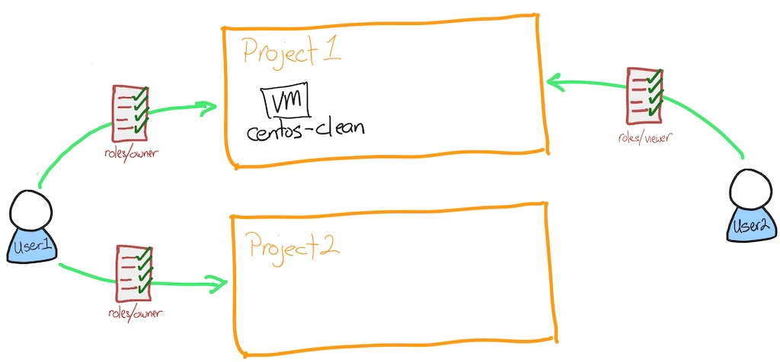

**What is IAM?**

Google Cloud offers Cloud Identity and Access Management (IAM), which lets you manage access control by defining who (identity) has what access (role) for which resource.

In IAM, permission to access a resource isn't granted directly to the end user. Instead, permissions are grouped into roles, and roles are granted to authenticated principals. (In the past, IAM often referred to principals as members. Some APIs still use this term.)

Identities

In Cloud IAM, you grant access to *principals*. Principals can be of the following types:

* Google Account
* Service account
* Google group
* Google Workspace account
* Cloud Identity domain
* All authenticated users
* All users

Learn more about these identity types from the [Concepts related to identity Guide](https://cloud.google.com/iam/docs/overview#concepts_related_identity).

In this lab, you use Google accounts, service accounts, and Cloud Identity domain groups.

Roles

A role is a collection of permissions. You cannot assign a permission to the user directly; instead you grant them a role. When you grant a role to a user, you grant them all the permissions that the role contains.

Learn more about roles from the [Roles Guide](https://cloud.google.com/iam/docs/overview#roles).

**What is gcloud?**

The gcloud CLI is a part of the Cloud SDK. You must download and install the SDK on your system and initialize it before you can use the gcloud command-line tool. You can use this tool to perform many common platform tasks either from the command-line or in scripts and other automations.

Learn more about gcloud from the [gcloud CLI overview Guide](https://cloud.google.com/sdk/gcloud/" \l "what_is_the_gcloud_command-line_tool" \t "_blank).

**Setup and requirements**

Before you click the Start Lab button

Read these instructions. Labs are timed and you cannot pause them. The timer, which starts when you click **Start Lab**, shows how long Google Cloud resources will be made available to you.

This hands-on lab lets you do the lab activities yourself in a real cloud environment, not in a simulation or demo environment. It does so by giving you new, temporary credentials that you use to sign in and access Google Cloud for the duration of the lab.

To complete this lab, you need:

* Access to a standard internet browser (Chrome browser recommended).

**Note:** Use an Incognito or private browser window to run this lab. This prevents any conflicts between your personal account and the Student account, which may cause extra charges incurred to your personal account.

* Time to complete the lab---remember, once you start, you cannot pause a lab.

**Note:** If you already have your own personal Google Cloud account or project, do not use it for this lab to avoid extra charges to your account.**Note:**For this lab, log in using **Username 1**.

How to start your lab and sign in to the Google Cloud console

1. Click the **Start Lab** button. If you need to pay for the lab, a pop-up opens for you to select your payment method. On the left is the **Lab Details** panel with the following:
   * The **Open Google Cloud console** button
   * Time remaining
   * The temporary credentials that you must use for this lab
   * Other information, if needed, to step through this lab
2. Click **Open Google Cloud console** (or right-click and select **Open Link in Incognito Window** if you are running the Chrome browser).

The lab spins up resources, and then opens another tab that shows the **Sign in** page.

***Tip:*** Arrange the tabs in separate windows, side-by-side.

**Note:**If you see the **Choose an account** dialog, click **Use Another Account**.

1. If necessary, copy the **Username** below and paste it into the **Sign in** dialog.

student-01-d2dc5cfbd865@qwiklabs.net

Copied!

content\_copy

You can also find the **Username** in the **Lab Details** panel.

1. Click **Next**.
2. Copy the **Password** below and paste it into the **Welcome** dialog.

XvFsyqZO9qyA

Copied!

content\_copy

You can also find the **Password** in the **Lab Details** panel.

1. Click **Next**.

**Important:**You must use the credentials the lab provides you. Do not use your Google Cloud account credentials.**Note:**Using your own Google Cloud account for this lab may incur extra charges.

1. Click through the subsequent pages:
   * Accept the terms and conditions.
   * Do not add recovery options or two-factor authentication (because this is a temporary account).
   * Do not sign up for free trials.

After a few moments, the Google Cloud console opens in this tab.

**Note:** To view a menu with a list of Google Cloud products and services, click the **Navigation menu** at the top-left. 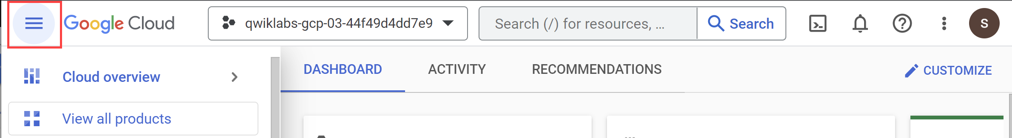

**Task 1. Configure the gcloud environment**

This lab already has a Compute Engine instance called **centos-clean** that simulates an environment that doesn't have gcloud installed. You connect to this instance using the Google Cloud console.

1. Open the list of compute instances by going to **Navigation Menu** > **Compute Engine** > **VM instances**.
2. On the line with the compute instance named **centos-clean**, click **SSH**.

**Note:**About Compute Engine instances: There are Windows and Linux types of instances. In this lab you use the Linux instance type. You can easily connect to Linux instances using the Secure Shell (SSH) client via the web browser.

You are automatically connected to the instance. Google Cloud manages the authentication keys for you, keeping them safe and available for only those you allow access.

1. First test, confirm that gcloud is successfully installed by checking the version. Inside the SSH session run:

gcloud --version

Copied!

content\_copy

Create a new instance and updating the default zone

After verification that gcloud command-line tool is installed , make some changes by creating a compute instance.

1. First, authenticate in gcloud. Inside the SSH session, run:

gcloud auth login

Copied!

content\_copy

Press ENTER when you see the prompt *Do you want to continue (Y/n)?*

1. Navigate to the link displayed in a new tab.
2. Click on your active username (student-01-d2dc5cfbd865@qwiklabs.net), and click **Allow**.
3. When you see the prompt **Enter the following verification code in gcloud CLI on the machine you want to log into**, click on the copy button then go back to the SSH session, and paste the code into the prompt **Enter authorization code:**.
4. In the SSH session, set the region and zone:

gcloud config set compute/region us-central1

gcloud config set compute/zone us-central1-c

Copied!

content\_copy

1. Inside the SSH session run:

gcloud compute instances create lab-1 --zone us-central1-c --machine-type=e2-standard-2

Copied!

content\_copy

If you have correctly set everything up, the command creates an instance.

But what size? And where? What image is used?

There are a number of defaults the service uses. Some can be controlled in the gcloud configuration. For example, the location of the instance is controlled by the zone setting.

Create an instance with name as lab-1 in Project 1

Check my progress

1. Check your current gcloud configuration. Inside the SSH session run:

gcloud config list

Copied!

content\_copy

You now see a compute section, a core section, and an active configuration. You can change each of these, but for this lab you'll only change the zone. Look at the zone your VM was created in.

1. Now list all the zones available to use by running the following inside the SSH session run:

gcloud compute zones list

Copied!

content\_copy

1. Identify one of the other zones in the same region as you. For example, if your current zone is us-west2-a, you could select us-west2-b.
2. Change your current zone for another zone in the same region. Inside the SSH session run the following, replacing ZONE with the zone you selected:

gcloud config set compute/zone ZONE

Copied!

content\_copy

1. Verify the zone change was made. Inside the SSH session run:

gcloud config list

Copied!

content\_copy

You see the stated zone reflects the change you made.

You can change other settings using the gcloud config set command. Those changes are permanent; they are written to your home directory.

The default configuration is stored in **~/.config/gcloud/configurations/config\_default**.

If you want to use a zone other than the default zone when creating an instance, you can use --zone switch. For example, gcloud compute instances create lab-1 --zone us-central1-f

Update the default zone

Check my progress

1. Verify the zone was written to the configuration file. Inside the SSH session run:

cat ~/.config/gcloud/configurations/config\_default

Copied!

content\_copy

You can see the configuration is just stored as text and can be backed up or copied.

**Task 2. Create and switch between multiple IAM configurations**

You have now set up one account. In situations when you need to work on different teams or access different accounts, you can also manage that with gcloud config.

In your next task you learn how to create a second configuration and switch between both of them.

Create a new IAM configuration

In this lab you have a second Google account you can log on with. This account has read-only (viewer) access to the first project. You create a new configuration for that user.

1. Start a new gcloud configuration for the second user account. Inside the SSH session run:

gcloud init --no-launch-browser

Copied!

content\_copy

1. Select option 2, *Create a new configuration*.
2. *configuration name*: Type **user2**.
3. *Log in with a new account*: select option 3 - you're logging in with the other provided user name.
4. Press ENTER when you see the prompt *Do you want to continue (Y/n)?*
5. Navigate to the link displayed in a new tab.
6. Click *Use another account*
7. Copy the second user account (student-01-c52562a03782@qwiklabs.net), and paste into the *email or phone* prompt.
8. Copy the same password that you started the lab with, and paste into the *enter your password* prompt.
9. Click **I understand**.
10. Click **Allow**.

You are accepting that the Cloud SDK has the same access as your Google account.

1. When you see the prompt **Enter the following verification code in gcloud CLI on the machine you want to log into**, click on the copy button then go back to the SSH session and paste the code into the prompt **Enter authorization code:**.
2. For **Pick cloud project to use:** locate your current project (qwiklabs-gcp-03-37b858de4384) and then type in the number that corresponds to the project.

The initialization completes and you see the zone and region are set for you.

Check gcloud user2 configuration was created

Check my progress

Test the new account

This new account has viewer only access to the project, so you can test that you are indeed using this account by trying to view and then create some resources.

1. Check that you can view details in the first project. Inside the SSH session run:

gcloud compute instances list

Copied!

content\_copy

The second user account has viewer access so you should see centos-clean and lab-1 instances listed.

1. Check that you cannot create an instance in the first project, as your assigned role is basic viewer. Inside the SSH session run:

gcloud compute instances create lab-2 --zone us-west1-c --machine-type=e2-standard-2

Copied!

content\_copy

Because the second user account has only viewer access, they are not allowed to create an instance, so this command fails. It takes a little time to fail.

1. Change back to your first user's configuration (**default**). Inside the SSH session run:

gcloud config configurations activate default

Copied!

content\_copy

You are now back to using your original user account credentials. Later you switch between these two accounts as you learn about roles and permissions.

When running a gcloud command, how do you override the configured zone for just that one time?



run the command gcloud config set zone DIFFERENT\_ZONE before you run the command.



Add the switch --project YOUR\_PROJECT\_ID to the command



Add the switch -zone DIFFERENT\_ZONE to the command

checkAdd the switch --zone DIFFERENT\_ZONE to the command

Submit

**Task 3. Identify and assign correct IAM permissions**

You have been provided two user accounts for this project. The first user has complete control of both projects and can be thought of as the admin account. The second user has viewer only access to the two projects. Call the second user a devops user and that user identity represents a typical devops level user.

Next you use gcloud to configure access to one project for the devops user by creating a custom role for the project that permits creation of buckets and instances.

Examine roles and permissions

1. To view all the roles, run the following inside the SSH session run:

gcloud iam roles list | grep "name:"

Copied!

content\_copy

The list of roles is returned. The addition of grep "name:" to the command reduces the amount of data returned to just the names of the roles.

Inspect one of these roles to see the permissions assigned to the role. To view the permissions use gcloud iam roles describe. Try looking at the simple role **roles/compute.instanceAdmin**.

1. Examine the compute.instanceAdmin predefined role. Inside the SSH session run:

gcloud iam roles describe roles/compute.instanceAdmin

Copied!

content\_copy

You can see **roles/compute.instanceAdmin** has many permissions, but these are the minimum needed for later:

* compute.instances.create
* compute.instances.delete
* compute.instances.start
* compute.instances.stop
* compute.instances.update
* compute.disks.create
* compute.subnetworks.use
* compute.subnetworks.useExternalIp
* compute.instances.setMetadata
* compute.instances.setServiceAccount

To review the full list of roles and the permissions assigned, refer to the [IAM permissions reference Guide](https://cloud.google.com/iam/docs/permissions-reference).

Grant access to the second user to the second project

Now that you know that roles contain permissions, how do you assign a role (and therefore all the associated permissions), to a user account?

There are two ways to attach a role:

* To the user and an organization
* To a user and a project

Next you attach the basic role of "viewer" to the second user onto the second project.

**Test that the second user doesn't have access to the second project.**

1. Switch gcloud configuration back to the second user (**user2**). Inside the SSH session run:

gcloud config configurations activate user2

Copied!

content\_copy

Now you're back to user2.

1. Set PROJECTID2 to the second project. Inside the SSH session, run the following:

echo "export PROJECTID2=qwiklabs-gcp-02-a336646400f3" >> ~/.bashrc

Copied!

content\_copy

. ~/.bashrc

gcloud config set project $PROJECTID2

Copied!

content\_copy

**Note:**This command appends the bashrc file, so be careful.

You get a warning: WARNING: You do not appear to have access to project [your 2nd project id] or it does not exist.

1. When prompted, *Do you want to continue (Y/n)?*, type N and press ENTER.

This means that user 2 doesn't have access to the PROJECTID2 project, which you fix in the next section.

**Assign the viewer role to the second user in the second project**

1. Switch back to the **default** gcloud configuration, which has the permission to grant access to the second user. Inside the SSH session run:

gcloud config configurations activate default

Copied!

content\_copy

1. Install jq:

sudo yum -y install epel-release

sudo yum -y install jq

Copied!

content\_copy

Next, set the value of USERID2 to the second user name and bind the role of viewer to the second user onto the second project.

1. Inside the SSH session, run the following:

echo "export USERID2=student-01-c52562a03782@qwiklabs.net" >> ~/.bashrc

Copied!

content\_copy

. ~/.bashrc

gcloud projects add-iam-policy-binding $PROJECTID2 --member user:$USERID2 --role=roles/viewer

Copied!

content\_copy

Once you have run the command, the text looks something like the following (you may need to scroll up):

Updated IAM policy for project [qwiklabs-gcp-02-a336646400f3].

bindings:

...

- members:

- serviceAccount:qwiklabs-gcp-02-a336646400f3@qwiklabs-gcp-02-a336646400f3.iam.gserviceaccount.com

role: roles/storage.admin

- members:

- user:student-01-d2dc5cfbd865@qwiklabs.net

- user:student-01-c52562a03782@qwiklabs.net

role: roles/viewer

Restricting Username 2 to roles/viewer in Project 2

Check my progress

**Task 4. Test that user2 has access**

1. Switch your gcloud configuration to **user2**. Inside the SSH session run:

gcloud config configurations activate user2

Copied!

content\_copy

1. Change the configuration for user2 to the second project. Inside the SSH session run:

gcloud config set project $PROJECTID2

Copied!

content\_copy

You should not see an error message this time.

1. Verify you have viewer access. Inside the SSH session run:

gcloud compute instances list

Copied!

content\_copy

You now see 0 instances in this project.

1. Try to create an instance in the second project as the second user. Inside the SSH session run:

gcloud compute instances create lab-2 --zone us-west1-c --machine-type=e2-standard-2

Copied!

content\_copy

This command fails because user2 only has viewer access to the project.

1. Switch your gcloud configuration to **default**. Inside the SSH session run:

gcloud config configurations activate default

Copied!

content\_copy

You are now back to using your original user account credentials.

Create a new role with permissions

Next, create the new role with the set of permissions needed for the devops team.

* Create a custom role called devops that has the permissions to create an instance. Inside the SSH session run:

gcloud iam roles create devops --project $PROJECTID2 --permissions "compute.instances.create,compute.instances.delete,compute.instances.start,compute.instances.stop,compute.instances.update,compute.disks.create,compute.subnetworks.use,compute.subnetworks.useExternalIp,compute.instances.setMetadata,compute.instances.setServiceAccount"

Copied!

content\_copy

This command creates a custom role in the project called devops with the permissions to create and manage instances.

The full name of the role is listed, note the role is in the project so the path is in the pattern of projects/PROJECT/roles/ROLENAME.

Create a new role with permissions for the devops team

Check my progress

Bind the role to the second account to both projects

You now have the role created and need to bind the user and the role to the project. Use gcloud projects add-iam-policy-binding to perform the binding. To make this command easier to execute, set a couple of environment variables first; the project id and the user account.

1. Bind the role of iam.serviceAccountUser to the second user onto the second project. Inside the SSH session run:

gcloud projects add-iam-policy-binding $PROJECTID2 --member user:$USERID2 --role=roles/iam.serviceAccountUser

Copied!

content\_copy

You need permissions to create an instance with a service account attached. The role iam.serviceAccountUser has those permissions, so use this pre-defined role.

student-01-c52562a03782@qwiklabs.net is bound to the role "roles/iam.serviceAccountUser", good job!

Check user2 is bound to project2 and the role roles/iam.serviceAccountUser

Check my progress

*student-01-c52562a03782@qwiklabs.net is bound to the role "roles/iam.serviceAccountUser", good job!*

1. Bind the custom role devops to the second user onto the second project. You can find the second user account on the left of this page. Make sure you set USERID to the second user account.

Inside the SSH session run:

gcloud projects add-iam-policy-binding $PROJECTID2 --member user:$USERID2 --role=projects/$PROJECTID2/roles/devops

Copied!

content\_copy

Once you have run the command, the text that looks something like the following (you may need to scroll up):

Updated IAM policy for project [qwiklabs-gcp-02-a336646400f3].

bindings:

- members:

- user:student-01-c52562a03782@qwiklabs.net@qwiklabs.net

role: projects/qwiklabs-gcp-02-a336646400f3/roles/devops

student-01-c52562a03782@qwiklabs.net is bound to the role "projects/qwiklabs-gcp-02-a336646400f3/roles/devops", good job!

Bound Username 2 to devops role

Check my progress

*student-01-c52562a03782@qwiklabs.net is bound to the role "projects/qwiklabs-gcp-02-a336646400f3/roles/devops", good job!*

Test the newly assigned permissions.

1. Switch your gcloud configuration to **user2**. Inside the SSH session run:

gcloud config configurations activate user2

Copied!

content\_copy

Now you're back to user2.

1. Try to create an instance called lab-2. Inside the SSH session run:

gcloud compute instances create lab-2 --zone us-west1-c --machine-type=e2-standard-2

Copied!

content\_copy

Now the instance creation works for user2.

lab-2 created, good job!

Create an instance with name as lab-2 in Project 2

Check my progress

*lab-2 created, good job!*

1. Verify the instance exists. Inside the SSH session run:

gcloud compute instances list

Copied!

content\_copy

Your environment

After these last changes your environment looks like this:

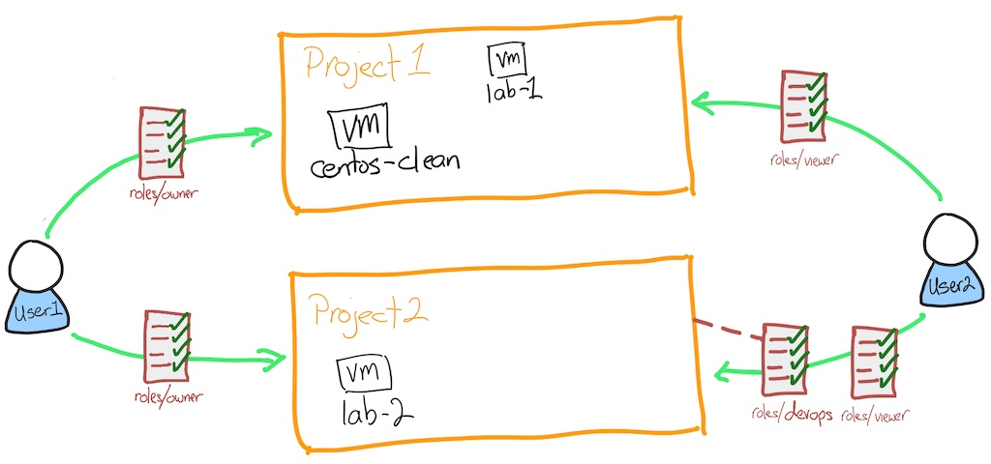

What are two of the three items you need to provide when binding an IAM role to a project?

checkproject id

checkaccount



service identifier



network



zone

Submit

**Task 5. Using a service account**

You have seen how to authenticate and use gcloud to access Google Cloud services with roles. Now you'll look at a typical approach.

You have an application that uses the Application Programming Interfaces (APIs) to read and write to Cloud Storage buckets. You don't want to have to authenticate every time you launch a new server, that would be both painful and not in the spirit of using the cloud! So, you use *service accounts*.

A service account is a special Google account that belongs to your application or a virtual machine (VM) instead of to an individual end user. Your application uses the service account to call the Google API of a service so that the users aren't directly involved.

Learn more about service accounts from the [Service accounts Guide](https://cloud.google.com/iam/docs/service-accounts).

Now you create a service account, use that service account with a compute instance, then test that the service account allows the access you need.

Create a service account

1. Switch your gcloud configuration to **default**, user2 doesn't have the rights to set up and configure service accounts. Inside the SSH session run:

gcloud config configurations activate default

Copied!

content\_copy

1. Set the project to PROJECTID2 in your configuration. Inside the SSH session run:

gcloud config set project $PROJECTID2

Copied!

content\_copy

Make sure you are targeting the right project.

1. Create the service account. Inside the SSH session run:

gcloud iam service-accounts create devops --display-name devops

Copied!

content\_copy

devops service account exists, good job!

Check the created devops service account

Check my progress

*devops service account exists, good job!*

1. Get the service account email address. Inside the SSH session run:

gcloud iam service-accounts list --filter "displayName=devops"

Copied!

content\_copy

**Note:**The filter shows only the line you are interested in. Notice that the email address contains the role name and the project id.

1. Put the email address into a local variable called SA. Inside the SSH session run:

SA=$(gcloud iam service-accounts list --format="value(email)" --filter "displayName=devops")

Copied!

content\_copy

This command sets the SA local variable to the email address of the service account. Pretty useful right?

1. Give the service account the role of iam.serviceAccountUser. Inside the SSH session run:

gcloud projects add-iam-policy-binding $PROJECTID2 --member serviceAccount:$SA --role=roles/iam.serviceAccountUser

Copied!

content\_copy

This role allows the service account to assign a service account to a compute instance.

devops@qwiklabs-gcp-02-a336646400f3.iam.gserviceaccount.com is bound to the role "roles/iam.serviceAccountUser", good job!

Check devops service account is bound to project2 and the role roles/iam.serviceAccountUser

Check my progress

*devops@qwiklabs-gcp-02-a336646400f3.iam.gserviceaccount.com is bound to the role "roles/iam.serviceAccountUser", good job!*

**Task 6. Using the service account with a compute instance**

1. Give the service account the role of compute.instanceAdmin. Inside the SSH session run:

gcloud projects add-iam-policy-binding $PROJECTID2 --member serviceAccount:$SA --role=roles/compute.instanceAdmin

Copied!

content\_copy

This role allows the service account to manage compute instances.

devops@qwiklabs-gcp-02-a336646400f3.iam.gserviceaccount.com is bound to the role "roles/compute.instanceAdmin", good job!

Check devops service account is bound to project2 and the role roles/compute.instanceAdmin

Check my progress

*devops@qwiklabs-gcp-02-a336646400f3.iam.gserviceaccount.com is bound to the role "roles/compute.instanceAdmin", good job!*

1. Create an instance with the devops service account attached. You also have to specify an access scope that defines the API calls that the instance can make. Inside the SSH session run:

gcloud compute instances create lab-3 --zone us-west1-c --machine-type=e2-standard-2 --service-account $SA --scopes "https://www.googleapis.com/auth/compute"

Copied!

content\_copy

Access scopes are the legacy method of specifying permissions for your instance. Access scopes are not a security mechanism. Instead, they define the default OAuth scopes used in requests from the gcloud tool or the client libraries. They have no effect when making requests not authenticated through OAuth, such as gRPC or the SignBlob APIs.

You must set up access scopes when you configure an instance to run as a service account.

A best practice is to set the full cloud-platform access scope on the instance, then securely limit the service account's API access with IAM roles.

Access scopes apply on a per-instance basis. You set access scopes when creating an instance and the access scopes persist only for the life of the instance.

Access scopes have no effect if you have not enabled the related API on the project that the service account belongs to. For example, granting an access scope for Cloud Storage on a virtual machine instance allows the instance to call the Cloud Storage API only if you have enabled the Cloud Storage API on the project.

devops@qwiklabs-gcp-02-a336646400f3.iam.gserviceaccount.com is attached as the service account, good job!

Check lab-3 has the service account attached

Check my progress

*devops@qwiklabs-gcp-02-a336646400f3.iam.gserviceaccount.com is attached as the service account, good job!*

**Task 7. Test the service account**

1. Connect to the newly created instance using gcloud compute ssh. Inside the SSH session run:

gcloud compute ssh lab-3 --zone us-west1-c

Copied!

content\_copy

Press ENTER when asked if you want to continue.

Press ENTER twice to skip making a password.

1. The default image used already contains gcloud configuration. Inside the SSH session run:

gcloud config list

Copied!

content\_copy

The configuration now has the service account

1. Create an instance. This tests that you have the necessary permissions via the service account:

gcloud compute instances create lab-4 --zone us-west1-c --machine-type=e2-standard-2

Copied!

content\_copy

You can press ENTER to accept the default zone for this VM.

1. Check roles attached are working. Inside the SSH session run:

gcloud compute instances list

Copied!

content\_copy

Because the service account has permissions, you can see the instances listed.

Your environment now looks like this

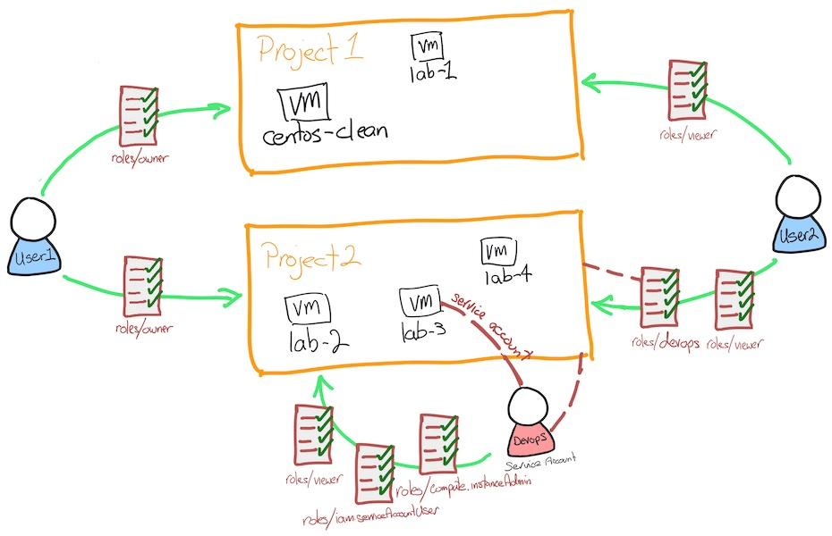

What is NOT true about service accounts?



Service accounts can be assigned only the rights necessary for the access required.



It prevents a user from directly getting involved in setting up access on the instance.



It allows automated deployments of resources.

checkService accounts always provide full admin rights to the project.

Submit

**Congratulations!**

You have completed the following tasks using the Cloud SDK tool, gcloud:

* Installed and configured the gcloud client
* Created and switched between multiple IAM configurations
* Identified and assigned correct IAM permissions
* Created and used a service account

Next steps / Learn more

* Documentation for [Cloud Identity and Access Management](https://cloud.google.com/iam/docs/overview)
* Check out these labs:
  + [BigQuery: Qwik Start - Command Line](https://google.qwiklabs.com/catalog_lab/684)
  + [Configuring Networks via gcloud](https://google.qwiklabs.com/catalog_lab/2047)

Google Cloud training and certification

...helps you make the most of Google Cloud technologies. [Our classes](https://cloud.google.com/training/courses) include technical skills and best practices to help you get up to speed quickly and continue your learning journey. We offer fundamental to advanced level training, with on-demand, live, and virtual options to suit your busy schedule. [Certifications](https://cloud.google.com/certification/) help you validate and prove your skill and expertise in Google Cloud technologies.

**Manual Last Updated April 10, 2024**

**Lab Last Tested April 10, 2024**

Copyright 2024 Google LLC All rights reserved. Google and the Google logo are trademarks of Google LLC. All other company and product names may be trademarks of the respective companies with which they are associated.